EX: 2 IMPLEMENT PROGRAMS FOR VISUALIZING DATE : TIME SERIES DATA

AIM:
The program visualizes and analyzes time series data using five techniques to identify trends, seasonality, distribution, and pattern.

ALGORITHM:
- Load the dataset and parse the date column.
- Set the date column as the index for time series analysis.
- Plot a line graph to visualize trends over time.
- Compute and plot the rolling mean for trend smoothing.
- Plot a histogram with KDE to analyze data distribution.
- Create a box plot by year to examine seasonal variations.
- Generate an autocorrelation plot to identify repeating patterns.
- Display all visualizations for interpretation.

PROGRAM:
# Install required libraries (if not already installed) import pandas as pd
import numpy as np

import matplotlib.pyplot as plt import seaborn as sns
from pandas.plotting import autocorrelation_plot

# Load the uploaded dataset

file_path = "/content/airline-passengers (1).csv"

df = pd.read_csv(file_path, parse_dates=["Month"], index_col="Month")

# Display the first few rows print("Dataset Preview:")
print(df.head())

# Set Seaborn style

sns.set(style="darkgrid")

# 1. LINE PLOT: Basic time series visualization plt.figure(figsize=(12, 6))
sns.lineplot(x=df.index, y=df["Passengers"], marker="o", linestyle="-", color="blue")
plt.xlabel("Date") plt.ylabel("Passengers")
plt.title("Airline Passengers - Line Plot") plt.xticks(rotation=45)
plt.show()

# 2. ROLLING MEAN PLOT: Trend smoothing using moving average

df["Rolling_Mean"] = df["Passengers"].rolling(window=12).mean() # 12-month moving average

plt.figure(figsize=(12, 6))

sns.lineplot(x=df.index, y=df["Passengers"], label="Original", alpha=0.5)

sns.lineplot(x=df.index, y=df["Rolling_Mean"], label="12-Month Rolling Mean", color="red")

plt.xlabel("Date") plt.ylabel("Passengers")
plt.title("Airline Passengers - Rolling Mean (Trend Analysis)") plt.legend()
plt.xticks(rotation=45) plt.show()

# 3. HISTOGRAM & KDE PLOT: Distribution of values plt.figure(figsize=(10, 5))
sns.histplot(df["Passengers"], kde=True, bins=20, color="green") plt.xlabel("Passengers")
plt.ylabel("Frequency")

plt.title("Distribution of Airline Passengers Data") plt.show()

# 4. BOX PLOT BY YEAR: Checking seasonality

df["Year"] = df.index.year # Extract year from date plt.figure(figsize=(12, 6))
sns.boxplot(x=df["Year"], y=df["Passengers"], palette="coolwarm") plt.xlabel("Year")
plt.ylabel("Passengers")

plt.title("Seasonality Check - Box Plot by Year") plt.xticks(rotation=45)
plt.show()

# 5. AUTOCORRELATION PLOT: Identifying repeating patterns plt.figure(figsize=(12, 6))
autocorrelation_plot(df["Passengers"])

plt.title("Autocorrelation Plot of Airline Passengers Data") plt.show()

OUTPUT:
Dataset Preview:

Passengers

Month
1949-01-01 | 112
1949-02-01 | 118
1949-03-01 | 132
1949-04-01 | 129
1949-05-01 | 121

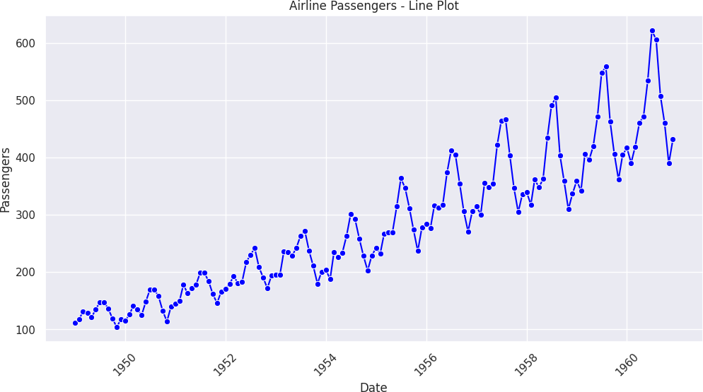

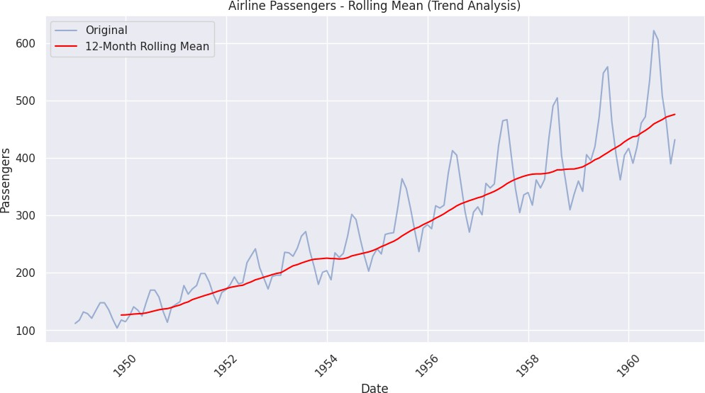

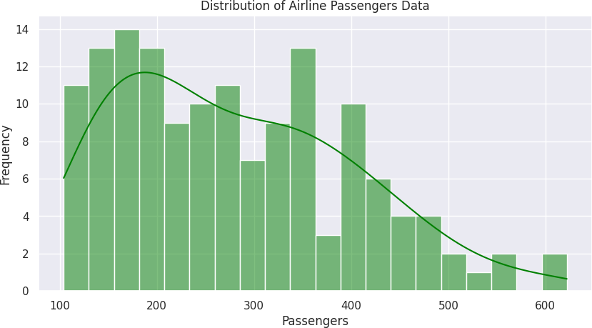

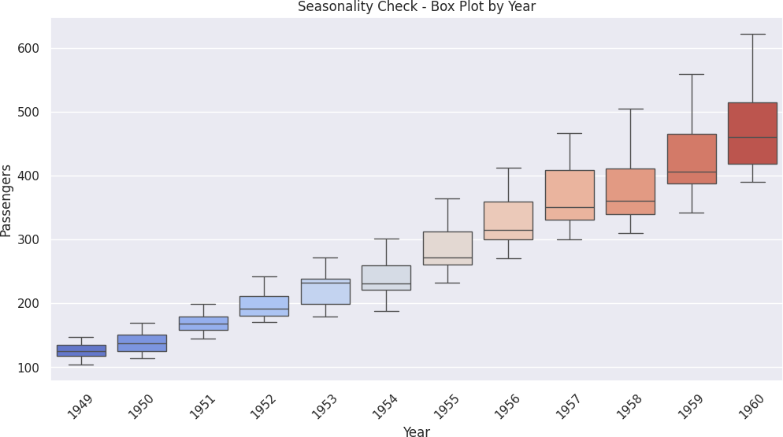

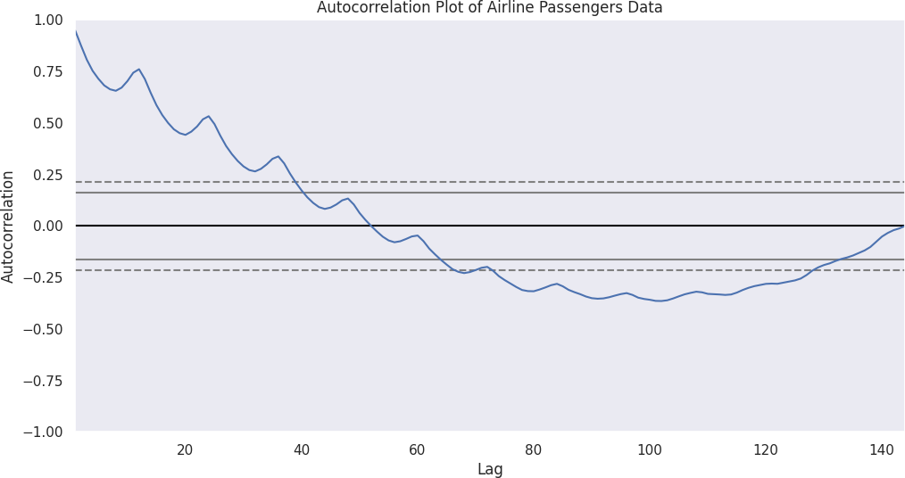

RESULT:
Thus, the visualization and analysis of the Airline Passengers Time Series Dataset were successfully completed.

